ORDER OF WORSHIP

April 29, 2018

“For God so loved the world that he gave his one and only Son, that whoever believes in him shall not perish but have eternal life.” John 3:16
WELCOME/ANNOUNCEMENT
PRELUDE: “Give Thanks” Smith

CALL TO WORSHIP
INVOCATIONAL PRAYER
CHORAL INTROIT
HYMN OF PRAISE: “There’s a Wideness in God’s Mercy” (Blue 355)
GREET ONE ANOTHER
CHILDREN’S SERMON
HYMN OF PREPARATION “O, How I Love Jesus” (Blue 92) (PRAYER CARDS may be passed to the ushers at the end of the aisles)
SCRIPTURE: Luke 16:19-31 (pg1626)
MORNING PRAYER
SPOTLIGHT ON MINISTRY
GIVING OF HIS TITHES AND OUR OFFERINGS
OFFERTORY CHANCEL CHOIR – “Always” soloist Christina Tello

DOXOLOGY Praise God from whom all blessings flow; Praise Him all creatures here below; Praise Him above, ye heavenly host; Praise Father, Son and Holy Ghost. Amen.

PRAYER OF DEDICATION

MESSAGE “God’s Whoever Policy”

HYMN OF RESPONSE “Just As I Am” (Blue 488)
BENEDICTION
POSTLUDE “Post As the Deer” Nystrom
*Electric Piano played by Cathy Applegate
Check our website, www.stpaulsbrick.org for last week’s message “Don’t Be Surprised!”
OUR GREETERS FOR TODAY’S SERVICES ARE:
9:00am: Jim and Claire Kroeze

10:45am: Mary Burns and Khaleel Russamano

ACOLYTES: Emily Chadwick and Siobhan Collis

THE FLOWERS ON THE ALTAR Given by Kristen Ebner in loving memory of Robert Trapanese


THE SIGN UP CHART FOR THE FLOWERS ON THE ALTAR IS IN THE NARTHEX.
We invite you to celebrate an event or remember loved ones by dedicating a flower arrangement to them. We all enjoy fresh flowers at our service each Sunday, and you are welcome to take them home after the second service. The flowers cost $25.00. We ask that you please use the envelopes provided for your payment when you sign up. Payment must be received to order flowers.
Thank you.

HELP US MINISTER TO YOU!

If you or anyone you know is ill or going into the hospital, please call the Church office and let us know: 732-458-2080.

New Members Class
Anyone interested in becoming a member here at St. Paul’s, we will be having our annual new members’ class start
THIS SUNDAY, April 29th at 6pm in the Library. The class will be for 4-6 weeks conducted by Pastor Alan Darby.

Any interest in this Class please inform Church Office and/or Pastor Alan.
732-458-2080

THIS WEEKS EVENTS

SUNDAY 04/29 9:00AM TradITIONAL WORSHIP Service - SANCTUARY
9:00 Childcare- Rm 2
9:00 SUNDAY SCHOOL K- HIGH SCHOOL
9:00 young adult sunday school
10:10 FELLOWSHIP-NORCROSS HALL
10:45 ContEMPORARY WORSHIP Service
10:45 ADULT BIBLE STUDY – YOUTH ROOM
5:00PM CONFIRMATION CLASS – LIBRARY
6:00 NEW MEMBERS CLASS - LIBRARY
6:00 JUNIOR HIGH YOUTH GROUP
8:00 ALCOHOLICS ANONYMOUS – NORCROSS HALL

MONDAY 04/30 6:00PM STRONGER HEARTS FOR CHRIST – NORCROSS
7:00 MUSTARD SEED BOARD MEETING - LIBRARY
7:00 BIBLE STUDY - STAFF LOUNGE

TUESDAY 05/01 NOON BULLETIN ANNOUNCEMENTS DUE
6:30 PRAYER AVALANCHE – CHAPEL
7:00 Men’s Prayer Group

WEDNESDAY 05/02 6:00am Men’S Breakfast
10:00 The Quilters - Youth Room
10:30 wOMEN’S SHARE GROUP- LIBRARY
4:30PM CHERUB CHOIR – 4 yr to 1st grade
6:00 VOLLEYBALL – Norcorss hall
6:00 HANDBELL CHOIR- MUSIC ROOM
7:00 mid-week worship – youth room
7:30 PRAISE TEAM PRACTICE - SANCTUARY

THURSDAY 05/03 NATIONAL DAY OF PRAYER- SEE BULLETIN INSERT
5:30 SENIOR HIGH YOUTH GROUP - PARSONAGE
6:00 STRONGER HEARTS FOR CHRIST- NORCROSS
7:00 TRUELIFE YOUTH GROUP – YOUTH ROOM
7:00 ADULT BIBLE STUDY – LIBRARY
7:00 BOY SCOUTS TROOP #33 – NORCROSS HALL
7:00 CAROL CHOIR – 2nd GRADE TO 5TH GRADE
7:00 CELEBRATION CHOIR – 6TH GRADE TO 12TH GRADE
8:00 CHANCEL CHOIR- MUSIC ROOM – 10TH GR.- ADULT

FRIDAY 05/04 8:30AM BULLETIN TEAM – LIBRARY
7:00PM FRIDAY NIGHT BIBLE STUDY – LIBRARY

SATURDAY 05/05 7:00AM MEN’S DISCIPLE – YOUTH ROOM
6:00PM FELLOWSHIP DINNER – NORCROSS HALL

SUNDAY 05/06 9:00AM TradITIONAL WORSHIP Service - SANCTUARY
9:00 Childcare- Rm 2
Sunday School Family Communion
Sunday
9:00 SUNDAY SCHOOL K- HIGH SCHOOL
9:00 young adult sunday school

10:10 FELLOWSHIP-NORCROSS HALL
10:45 ContEMPORARY WORSHIP Service
10:45 ADULT BIBLE STUDY – YOUTH ROOM
5:00pm CONFIRMATION CLASS – LIBRARY
6:00 NEW MEMBERS CLASS - LIBRARY
6:00 JUNIOR HIGH YOUTH GROUP
8:00 ALCOHOLICS ANONYMOUS – NORCROSS HALL


Our weekly events are updated frequently to keep you posted on the happenings of the church.
https://www.facebook.com/stpaulsbrick/

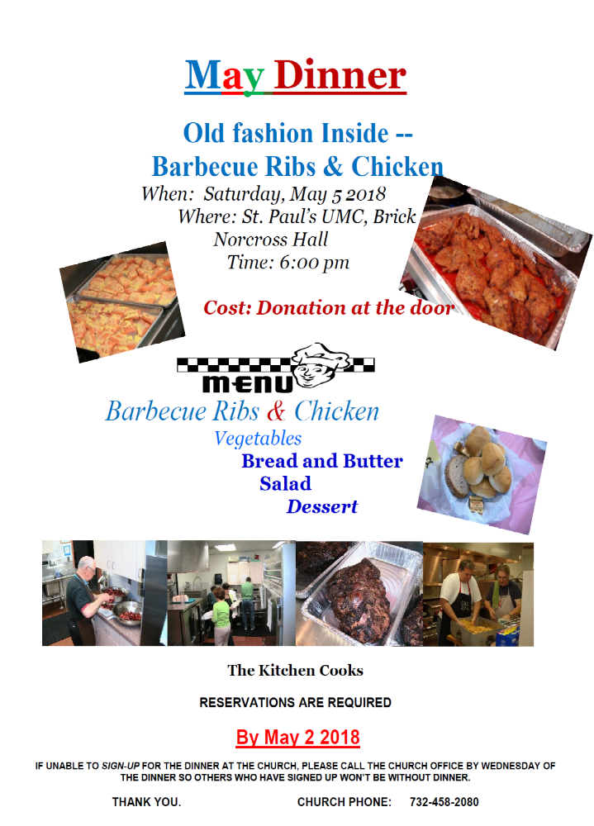

RECORD OF FAITHFULNESS

April 22, 2018

Worship Attendance Last Sunday 197
Sunday School 54

Giving Current Expenses Mortgage Giving

Received last Week $6,176 $1,215
Need per Week $9,348

The amount shown as Received last Week includes offerings received at last week’s Sunday services. Note: envelope giving includes only the amount on the TITHE/UNIFIED line.
MORTGAGE UPDATE:

The mortgage balance as of April 1, 2018 is $863,923

Communications

E-Mail Announcements and Prayer Requests
If you would like to be on the church e-mail list to receive announcements, reminders of upcoming events and prayer requests, e-mail your information to penrodt@Comcast.net.
Telephone Prayer Ministry
Nancy Penrod 732-458-7641 or church office 732-458-2080.

All Circuit Rider articles should be emailed to Nancy Penrod at penrodt@Comcast.net. If you do not have access to a computer you can drop it off in the office or call Nancy at 732 458-7641. All articles should be sent to Nancy by the 10th of the month prior to publication.

Bulletin Notices-All information to be included in the Bulletin is due to the church office by Tuesday at Noon. If you have access to e-mail, please send your Bulletin announcement via e-mail to Office@stpaulsbrick.org.

PASTORAL STAFF
Alan Darby PastorAl@stpaulsbrick.org Pastor
Hector Meza Hector.Meza@stpaulsbrick.org Dir. Of Youth Ministries
Barbara Estelle Bestelle@stpaulsbrick.org Dir. Music/Organist
Judy Propert, Janet Post Choir Directors
Cathy Applegate, Pam Snyder Choral Accompanists
Peggy Blomquist, Judy and Bill Propert Congregational Care
Melissa Jensen Office@stpaulsbrick.org Administrative Asst.
Bill Nadler, Gary Deal, Kim Gavaletz, Mike Jensen, Al Primrose, Kevin Albora Sextons

Website Address: http://www.stpaulsbrick.org
Church Office Office@stpaulsbrick.org

MISSIONARIES
Andy & Lizet Bowen andy.bowen@wgm.org Paraguay
Joy Phillips Joy.Phillips@wgm.org Kenya
Billy and Joanna Coppedge Uganda
Step of Faith stepoffaithministries.org Haiti
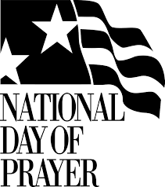

St. Paul’s Chapel Will Be Open All Day

Thursday, May 3, 2018
Sanctuary Open 9:30am to 6:30pm
Small Study and Prayer Group at 7:00pm

Mark the Date!

All Are Invited. All Are Welcome.
The National Day of Prayer is an annual observance held on the first Thursday of May, inviting people of all faiths to pray for the nation. It has been a vital part of our heritage since 1775, when the Continental Congress asked the colonies to pray for wisdom in forming a nation. It exists today to communicate with every individual the need for personal repentance and prayer and to mobilize the Christian community to intercede for America’s leaders and its families. The NDP Task Force represents a Judeo-Christian expression of the national observance, based on the understanding that this country was birthed in prayer and in reverence for the God of the Bible.
Blessed is the nation whose God is the LORD. Psalm 33:12
Need Help- Volunteer to Help With Rummage Sale! Look Below to See Where YOU Can Help the Most!
Set up on Friday, May 18th from 8am – 6:30pm
- Help needed to receive, sort and organize donations. Any time slot appreciated. Much can be done in just one hour.

Work Rummage Sale Saturday, May 19th 10-2pm

- Assist on sales floor
- Check-out help
- Kitchen help
- Bake sale table
- Kitchen food sales
- White elephant sales

UMW Circle Meetings for May
All ladies are welcome! If you’ve ever wondered what goes on at our monthly UMW circle get-togethers, just ask us! Better yet, try one. You might just get hooked! We study God’s word. We share. We laugh. We learn about each other. We love the Lord together. And … we do all this by meeting up just once a month. Our hope is that one of these meeting dates will fit into your busy schedule. Why not give it a try? What have you got to lose? More importantly, what have you got to gain? We think a whole lot!
Rebecca Circle, Tuesday, May 8th. Call Ruth Baker for more information at (732) 458-2712
Sarah Circle, Tuesday, May 8th. Call Carol Kampf for more information at (732) 840-9496 or email Carol at carolkampf@yahoo.com
Miriam Circle, Tuesday, May 8th. Call Cathy Porzio for more information at (732) 458-8232 or email Cathy at cporzio@verizon.net
Lydia Circle, Wednesday, May 9th. Call Margie Moss for more information at (732) 458-4857 or email Margie at mmoss77@comcast.net
Martha Circle, Sunday, May 13th. Free childcare provided. Call Diane Collis for more information at (732) 785-2750 or email Diane at dcollis19@gmail.com
INTERCESSORY PRAYER
April 22, 2018

“And if the Spirit of him who raised Jesus from the dead is living in you, he who raised Christ form the dead will also give life to your mortal bodies because of his Spirit who lives in you.” Romans 8:11

HEALING – Dawn healing of cancer; from the spirit of fear; friend’s 18yo daughter still suffering from depression; coworker Jackie during her cancer treatments -Cathy Straehle; Mike G to heal his foot & his sickness; family of Charlie Calabrese, P Venice from surgery & infection; friends and family with cancer; friend with heart problems, going through testing for heart, friend getting PET scan; Lorraine, Barbara Marks, Terry & Nancy, Maureen’s back, Maureen’s sister in law, Bev Darby; Nick, Dan, Jane, Lorraine H, Lorraine B, Mick, Cynthia, Betty, Bill, Charlie, Bill K, Robert, Terry, Nancy, Judy, Becky, Bev, Ed, 3 young children w/ emotional problems; caregivers strength & patience, soften Anne & Amy hearts; families caring for cancer suffers; Lee, Lorraine, Jim having stem cell treatment for leukemia, Anne, Tarah; the family of Lenny Savino, co-workers -Diane, Nancy, Terry and Nilda all who are dealing with serious health issues; John eye operation on Monday, Jackie friend -Joy; Mike B for serious health issue, dad recovering at home; Betty, Lorraine, myself in dealing with depression again; Stacy & Bill who lost their son Tripp; Anita F, Mary Jean M, Perla M; Pat with cancer; Tina with breast cancer, son in laws grandfather Siroan in the hospital at 92; Uncle Frank, Dads truck, Doug, Jordan & Jared, Uncle Chris, Uncle Peter, Nanny, Grammy, Mom; for my family; Mia Sidorakis continue to fight a brain tumor; Mike chronic lung problems, relief; Wright family Victoria, Raymond, Gornstein family, Maglione and Weissingers; Alma -lymphedema and depression, Andre & Jim -leukemia, Trish -back trouble, Jan, Denise & Martha -breast cancer, Kate B -ovarian cancer, Ray -depression, Daron, Paula, Melissa, George, Armani & Victoria; Perez family in their mourning; Rob with chronic pain; comfort & hope for John with cancer.

PROTECTION – The military; Mana, Anna, Elijah & Harry; Marie, Elijah, Harry & Anna, Lord I ask for your protection over my children as their baseball season starts; bless me at my new job; Bless Juliana during her heart operation Wednesday; those in the military.

“Dear children, let us not love with words or speech but with actions and in truth.” 1John 3:18

PRAISE – Thank you Lord for always providing our every need, for all my family bless and care for all. Thank you for answer prayers; Ricks new tenants; families continued good health; sale of house going smoothly may all continue; Servicemen and women around the world; Thank you for all the yesterdays, todays & tomorrows. Let us enjoy today and not waste it by looking to the future; Victoria is beginning to gain strength & light sensitivity and migraine bearable after lumbar puncture Thursday; answered prayers; young people who feel free to left up their voices.

GUIDANCE – Prayers for family, Jacklyn; new home and job; Kelly family, servicemen & women; Bless me to be your messenger of peace and love to everyone I meet each day at home & at work; Jeff to find an internship this summer; Lead Dweep and I through our interview. Give us courage and wisdom through all this. Pray for office and lawyer. Help us to honor and glorify you; for my grandkids, keep them on the right path in life; St Pauls church & leaders; Nick -prayers for strength, Sarah -strength; Money matters, unspoken prayers for friends; Rob get help with problems; Damien in NY with college & his music; daughter as she lost her job after 23 years and purchased a new home – depression and find work; Tracy & her family, Dad & Ellen, Reed family near & far; college students traveling; bless me Lord with your love.

TRAVEL MERCIES – As I go to Charleston this week with my daughter; Dan as he goes to Germany with his history class; Shelby & those on spring break; Bryan traveling for spring break; new drivers; for all traveling.

“Finally, be strong in the LORD and in his mighty power. Put on the full armor of God, so that you can take your stand against the devil's schemes.” Ephesians 6:10-11

SALVATION – Alec and family; Mike G and wife.

MUSTARD SEED SCHOOL NEWS- AND UPDATE

Last fall the children planted spring bulbs around the playground fence. When spring finally came and we were able to go to the playground, we were very excited to see the flowers blooming. There is a new flower almost everyday. Sometimes we have to wait for beautiful, wonderful things. God is good and I praise him for his help and direction.


I have been working with two people from the Office of Licensing trying to complete our paperwork for our license. Please pray that we will resolve the Certificate of Occupancy issues and that our environmental studies will be finished and handed over to the state Please also pray that we will not require the Department of Health to come for further environmental studies.
Thank for your support and help.
Donna Ferguson



St. Paul’s UMW’s Annual Spring

Rummage Sale

Saturday, May 19, 2018

10am - 2pm

Please help spread the word.

Remember – Any donation of clothing, linens, jewelry and white elephant items are greatly appreciated and may be brought to Norcross Hall on Friday, May 18th from 8am until 6:30pm.

Items we will NOT be accepting:

Box TV’s and Computers

Medical Equipment

Large Furniture

Large Appliances

Electronics

Encyclopedias or Text Books

Mattress/Box Springs/Bed Pillows

Tires

Lawn Mowers/Weed Wackers

Recalled Infant Items

Donated baked goods are always a big hit!
Please drop them off by 10:00 a.m. on sale day.

As always…all profits support the
many missions of the U.M.W.!

VACATION BIBLE SCHOOL 2018

Our program this year is SHIPWRECKED: Rescued By Jesus

WE NEED YOUR HELP! We can’t do it without you!

Our VBS program will take place the week of July 30th through August 3rd.

I can help with VBS by:
____leading a class ____assisting with a class
____ DECORATING ____VBS mailings ____set design
If you can volunteer please contact Ciara Cavanagh, Judy Tomes or Jan Primrose @ 732/840-2186.

If you are interested in helping to enrich the life of a child, please complete the form below and place in the offering plate or the VBS mailbox.

Name _________________________________________

Phone ________________________________________

E-Mail ________________________________________

Days Available: (please circle) M Tu W Th Fr All Week

ALSO: STUDENT REGISTRATION WILL OPEN JUNE 1st! Accepting children ages 4 through Grade 5.

